INTRODUCION

Overview:

To invite people for freshers party in our college

Purpose:

To promote good thoughts our college

PROBLEM DEFINITION &DESIGN THINKING

Empathy map:

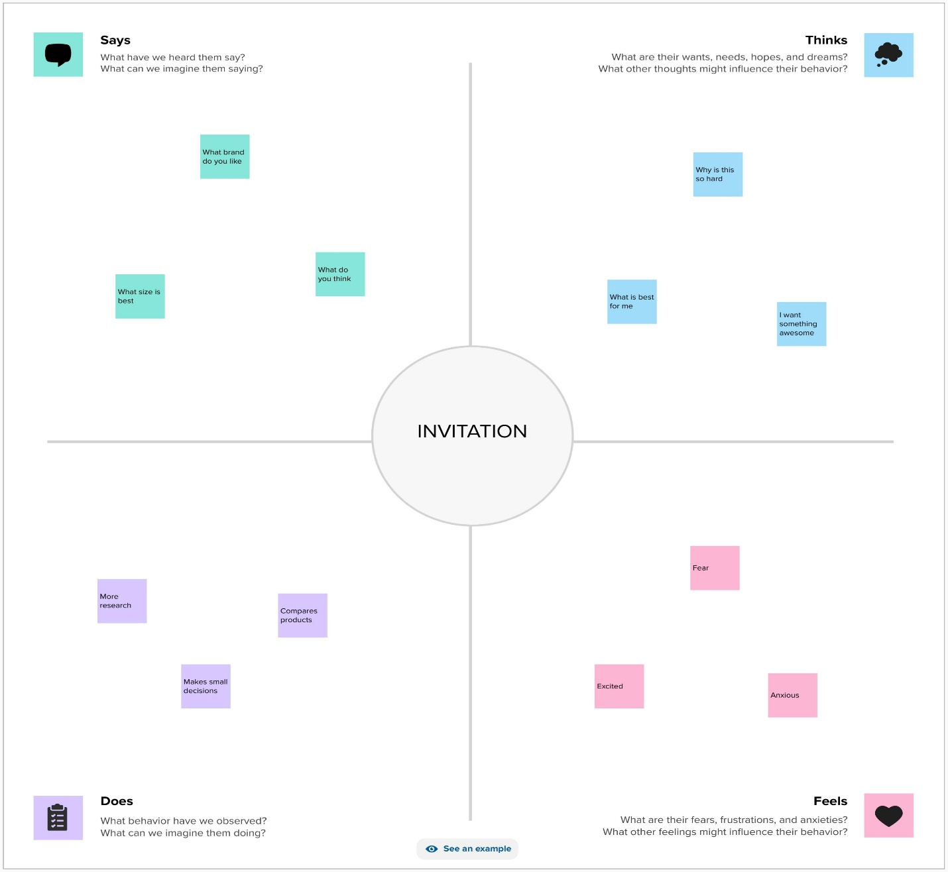

Brain storm:

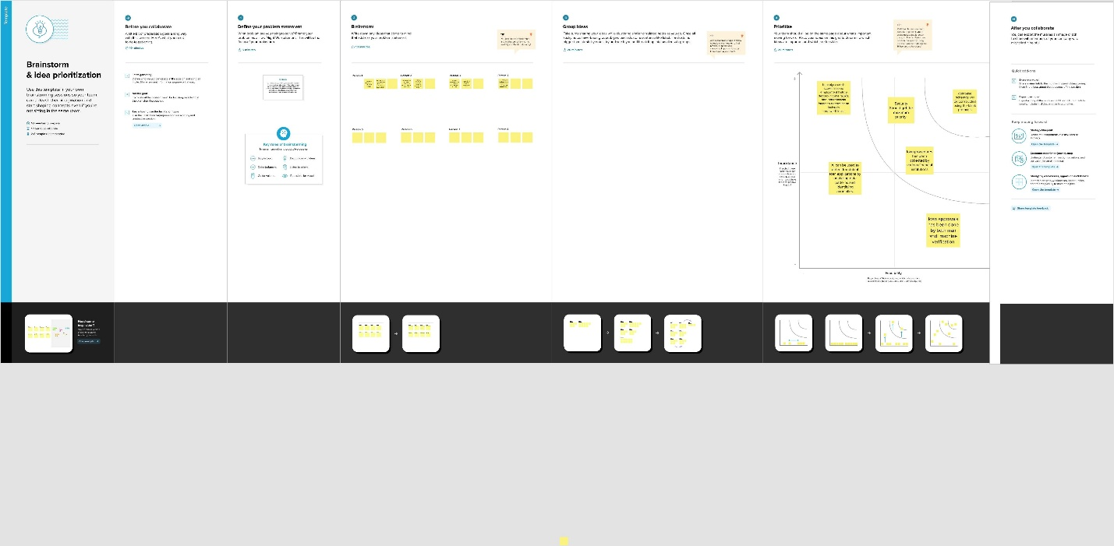

RESULT

Successfully great the invitation for the freshers party

* It reach as all student and parents esaily
* Some students may not attend the freshers party

APPLICATION:

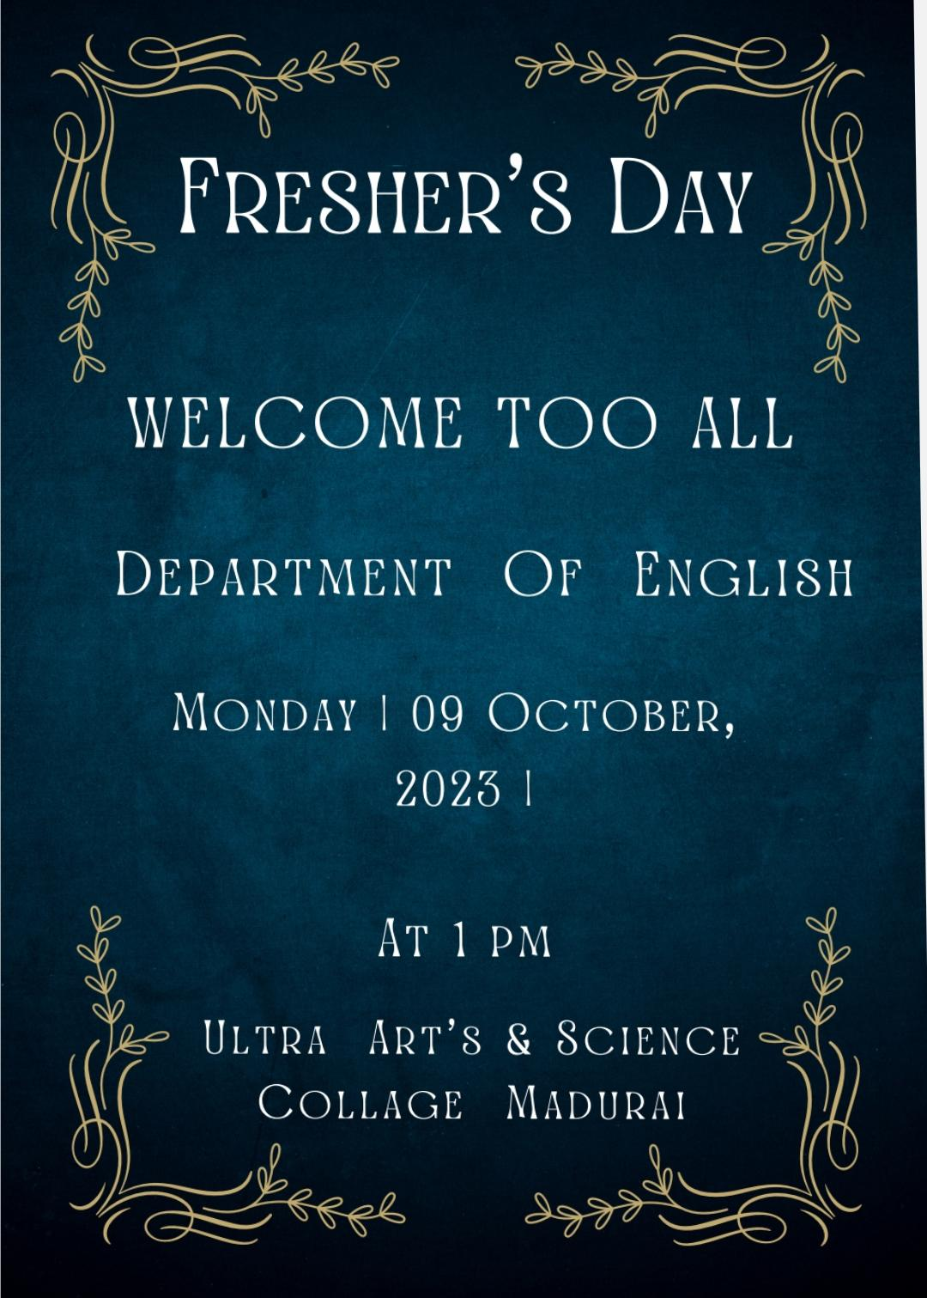

CONCLUSION:

With the help of canva app with esaily